**Final Report – II**

**(2019-2020)**

**Face Detection and Recognition**



**Institute of Engineering & Technology**

**Team Members**

Vinit Singh

(161500621)

Rishansh Tiwari

(161500456)

Yash Singh

(161500640)

Vishal Verma

(161500625)

Shubham Sharma

(161500547)

**Supervised By**

**Mr. Vivek Kumar**

**ASST. PROFESSOR**

**Department of Computer Engineering & Applications**

**DECLARATION**

*We hereby declare that the work which is being presented in the Mini Project “****Face detection and recognition”,****in partial fulfillment of the requirements for Mini-Project LAB, is an authentic record of our own work carried under the supervision of* ***Mr.Vivek Kumar, Asst.Professor, GLA University, Mathura****.*

**Name of Students with signature**

**CERTIFICATE**

This is to certify that the project entitled **“FACE DETECTION AND RECOGNITION”** carried out in Mini Project –II Lab is a bonafide work done by **Vinit Singh *(161500621), Rishansh Tiwari(161500456)*,Yash singh *(161500640),* Vishal verma*(161500625) and Shubham Sharma (161500547)*** and is submitted in partial fulfillment of the requirements for the award of the degree Bachelor of Technology (Computer Science & Engineering).

**Signature with date**

**Name of Supervisor:**

**Date:**

**ACKNOWLEDGEMENT**

*It gives us a great sense of pleasure to present the report of the B. Tech Mini Project undertaken during B. Tech. Third Year. This project in itself is an acknowledgement to the inspiration, drive and technical assistance contributed to it by many individuals. This project would never have seen the light of the day without the help and guidance that we have received.*

*Our heartiest thanks to* ***Dr. (Prof). Anand Singh Jalal,*** *Head of Dept., Department of CEA for providing us with an encouraging platform to develop this project, which thus helped us in shaping our abilities towards a constructive goal.*

*We owe special debt of gratitude to* ***Mr. Vivek KUMAR,*** *Assistant Professor Department of CEA, for his constant support and guidance throughout the course of our work. His sincerity, thoroughness and perseverance have been a constant source of inspiration for us. He has showered us with all his extensively experienced ideas and insightful comments at virtually all stages of the project & has also taught us about the latest industry-oriented technologies.*

*We also do not like to miss the opportunity to acknowledge the contribution of all faculty members of the department for their kind guidance and cooperation during the development of our project. Last but not the least, we acknowledge our friends for their contribution in the completion of the project.*

Vinit Singh

Rishansh Tiwari

Vishal Verma

Yash Singh

Shubham Sharma

**ABSTRACT**

Identifying a person with an image has been popularised through the mass media. However,it is less robust to fingerprint or retina scanning. This report describes the face detection andrecognition project undertaken for the visual perception and recognition of faces for various application like attendence in colleges using face recognition and detection module at GLA University. It reports the technologies available in the Open-Computer-Vision (OpenCV) library andmethodology to implement them using Python. For face detection, Haar-Cascades were used andfor face recognition Eigenfaces, Fisherfaces and Local binary pattern histograms(LBPH) were used. Themethodology is described including flow charts for each stage of the system. Next, the results areshown including plots and screen-shots followed by a discussion of encountered challenges.

**Table of Contents**

|  |  |
| --- | --- |
| 1. **Introduction**    1. **Overview and Motivation**   **1.2 Objective** | 1 |
| 1. **Project Design**    1. **Data flow diagram**    2. **Uml diagram** | 4 |
| 1. **Implementation** | 7 |
| 1. **References/Bibliography** | 8 |
| 1. **Appendices** | 9 |

# 1. INTRODUCTION

# The following document is a report on the project for face detection and recognition. Itinvolved building a system for face detection and face recognition using several classifiers available inthe open computer vision library(OpenCV). Face recognition is a non-invasive identication system andfaster than other systems since multiple faces can be analysed at the same time. The difference betweenface detection and identication is, face detection is to identify a face from an image and locate the face.Face recognition is making the decision "whose face is it ? ", using an image database. In this projectboth are accomplished using different techniques and are described below. The report begins with a overview and motivation of face recognition. This is followed by the project design and explanation of HAAR-cascades, Eigenface, Fisherfaceand Local binary pattern histogram (LBPH) algorithms. A discussion regarding the challenges and the resolutions are described. Finally, a implementation and conclusion is provided on the pros and cons of each algorithm and possible implementations.Face recognition is a task so common to humans, that the individual does not even notice the extensive number of times it is performed every day. Although research in automated face recognition has been conducted since the 1960’s, it has only recently caught the attention of the scientific community. Many face analysis and face modeling techniques have progressed significantly in the last decade. However, the reliability of face recognition schemes still poses a great challenge to the scientific community. Falsification of identity cards or intrusion of physical and virtual areas by cracking alphanumerical passwords appear frequently in the media. These problems of modern society have triggered a real necessity for reliable, user-friendly and widely acceptable control mechanisms for the identification and verification of the individual.

* 1. **OVERVIEW AND MOTIVATION**

The motivation behind this project is that facial detection has an amplitude of possible applications. From common household objects like digital cameras that automatically focus on human faces to security cameras that actually match a face to a person’s identity. Webcams are often used as a security measure for locking a personal computer. The webcam’s facial recognition technology allows for the computer to be accessible to the user only if it recognizes their face.Cameras can also use this technology to track human faces and keep a count of the number of people in a shot or in a certain location or even coming in through an entrance. This technology can be further narrowed down to the recognition and tracking of eyes. This would save power by dimming a screen if viewer is not looking. For this project, we hope to use an already existing algorithm as a basis for face detection and build upon it to create improvements and explore more data.Face recognition has recently received a blooming attention and interest fromthe scientific community as well as from the general public. The interest fromthe general public is mostly due to the recent events of terror around the world,which has increased the demand for useful security systems.To construct these different applications, precise and robust automated facialrecognition methods and techniques are needed. However, these techniquesand methods are currently not available or only available in highly complex,expensive setups.The topic of this thesis is to help solving the difficult task of robust face recognitionin a simple setup. Such a solution would be of great scientific importanceand would be useful to the public in general.

**1.2 OBJECTIVE OF FACE RECOGNITION**

The objectives of this thesis will be:

• To discuss and summarize the process of facial recognition.

• To look at currently available facial recognition techniques.

• To design and develop a robust facial recognition algorithm. The algorithm should be usable in a simple and easily adaptable setup. This implies a single camera setup, preferably a webcam, and no use of specialized equipment.

Besides these theoretical objectives a proof-of-concept implementation of the developed method will be carried out.

1. **PROJECT DESIGN**

This section consist of the design details of the face recognition and detection project which includes data flow diagram and uml diagram of the face recognition and detection.With the help of data flow diagram we see the closer view of the design of the project and understand what are basic and main ideas involve in the project.

* 1. **DATA FLOW DIAGRAM**

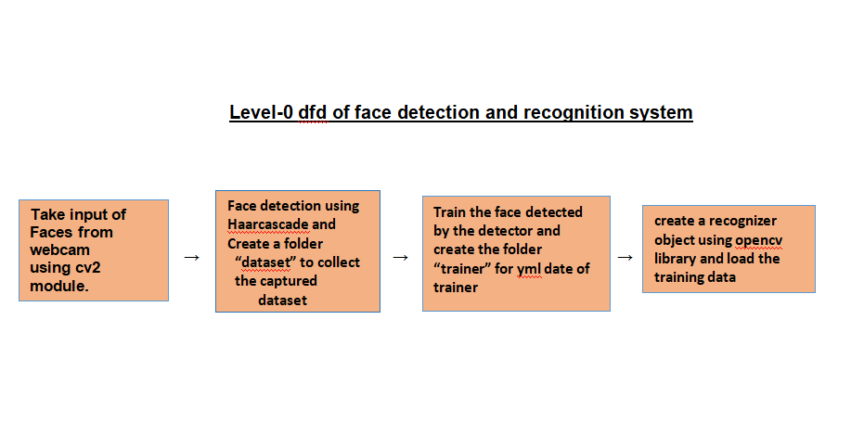

**Explanation of above dfd:**

**First our dataset generator is going to capture few sample faces of one person from the live video frame and assign a ID to it and it will save those samples in a folder which we are going to create now and we will name it “dataSet”**

**Now to perform face recognition we need to train a face recognizer, using a pre labeled dataset,that dataset which we created using dataset generator in first step.**

**Now at last we are going to use that training data(“trainer.yml”) to recognize some faces we previously trained.**

* 1. **UML DIAGRAM FOR FACE DETECTION AND RECOGNITION**

**Basic uml approach**

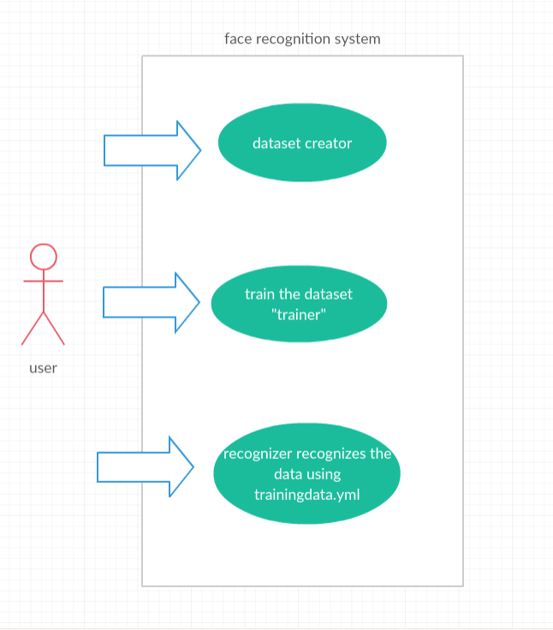

1. **IMPLEMENTATION**

Here in implementation we discuss about the ideas behind the working of face recognition system and how it works?

To make a face recognition program, first we need to train the recognizer with dataset of previously captured faces along with its ID, for example we have two person then first person will have ID 1 and 2nd person will have ID 2, so that all the images of person one in the dataset will have ID 1 and all the images of the 2nd person in the dataset will have ID 2, then we will use those dataset images to train the recognizer to predict the 1 of an newly presented face from the live video frame.

The major parts of the program are:-

* Dataset Creator
* Trainer
* Detector

The whole program which is made using above three major parts i.e dataset creator,trainer and detector is shown in appendices of this report which shows the working of the face detection and recognition in realtime.

1. **REFRENCES**

• Adelson, E. H., and Bergen, J. R. (1986) The Extraction of Spatio-Temporal Energy in

• Human and Machine Vision, Proceedings of Workshop on Motion: Representation and

• Analysis (pp. 151-155) Charleston, SC; May 7-9

• Baron, R. J. (1981). Mechanisms of human facial recognition. International Journal of Man Machine Studies, 15:137-178

• Beymer, D. and Poggio, T. (1995) Face Recognition From One Example View, A.I. Memo No. 1536, C.B.C.L. Paper No. 121. MIT

• Brennan, S. E. (1982) The caricature generator. M.S. Thesis. MIT.

• Brunelli, R. and Poggio, T. (1993), Face Recognition: Features versus Templates. IEEE Transactions on Pattern Analysis and Machine Intelligence, 15(10):1042-1052

• Craw, I., Ellis, H., and Lishman, J.R. (1987). Automatic extraction of face features. Pattern Recognition Letters, 5:183-187, February.

• Deffenbacher K.A., Johanson J., and O'Toole A.J. (1998) Facial ageing, attractiveness, and distinctiveness. Perception. 27(10):1233-1243

• Dunteman, G.H. (1989) Principal Component Analysis. Sage Publications.

1. **APPENDICES**

SAMPLE CODE AND SCREENSHOT OF FACE DETECTION AND RECOGNITION

Three major parts which makes the face recognition application:

Dataset generator:

Code Screenshot:datasetCreator.py

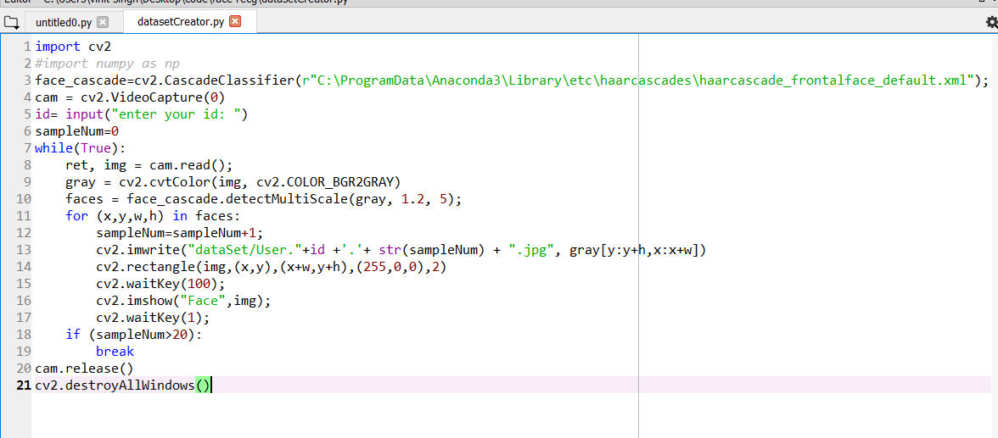

Trainer:

Code Screenshot:trainer.py

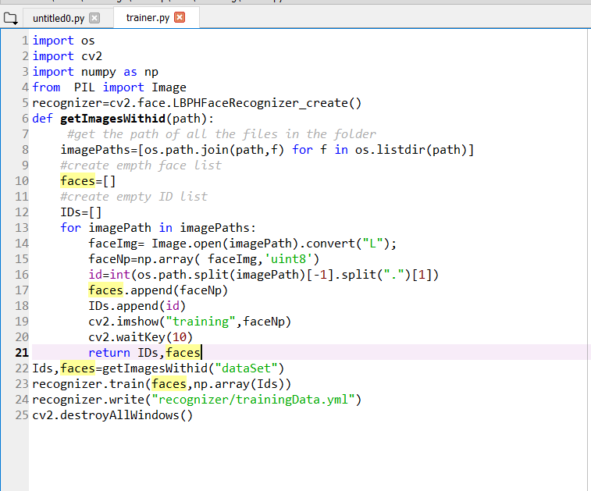

Recognizer:

Code Screenshot:-detector.py

